Swaziland

## Population Data

The data set shows the political stability estimate of the country each year.

## # A tibble: 23 x 5  
## country iso3c date population popCategory5  
## <chr> <chr> <dbl> <dbl> <chr>   
## 1 Eswatini SWZ 1996 945508 very small   
## 2 Eswatini SWZ 1997 963426 very small   
## 3 Eswatini SWZ 1998 979918 very small   
## 4 Eswatini SWZ 1999 994108 very small   
## 5 Eswatini SWZ 2000 1005435 very small   
## 6 Eswatini SWZ 2001 1013609 very small   
## 7 Eswatini SWZ 2002 1019059 very small   
## 8 Eswatini SWZ 2003 1022802 very small   
## 9 Eswatini SWZ 2004 1026286 very small   
## 10 Eswatini SWZ 2005 1030579 very small   
## 11 Eswatini SWZ 2006 1036092 very small   
## 12 Eswatini SWZ 2007 1042652 very small   
## 13 Eswatini SWZ 2008 1049945 very small   
## 14 Eswatini SWZ 2009 1057467 very small   
## 15 Eswatini SWZ 2010 1064837 very small   
## 16 Eswatini SWZ 2011 1072032 very small   
## 17 Eswatini SWZ 2012 1079288 very small   
## 18 Eswatini SWZ 2013 1086839 very small   
## 19 Eswatini SWZ 2014 1095021 very small   
## 20 Eswatini SWZ 2015 1104044 very small   
## 21 Eswatini SWZ 2016 1113984 very small   
## 22 Eswatini SWZ 2017 1124753 very small   
## 23 Eswatini SWZ 2018 1136191 very small

# Population growth data

## # A tibble: 23 x 5  
## country iso3c date popGrowth popGrowthCat5   
## <chr> <chr> <dbl> <dbl> <chr>   
## 1 Eswatini SWZ 1996 1.99 moderate growth rate  
## 2 Eswatini SWZ 1997 1.88 moderate growth rate  
## 3 Eswatini SWZ 1998 1.70 moderate growth rate  
## 4 Eswatini SWZ 1999 1.44 slow growth rate   
## 5 Eswatini SWZ 2000 1.13 slow growth rate   
## 6 Eswatini SWZ 2001 0.810 slow growth rate   
## 7 Eswatini SWZ 2002 0.536 slow growth rate   
## 8 Eswatini SWZ 2003 0.367 slow growth rate   
## 9 Eswatini SWZ 2004 0.340 slow growth rate   
## 10 Eswatini SWZ 2005 0.417 slow growth rate   
## 11 Eswatini SWZ 2006 0.534 slow growth rate   
## 12 Eswatini SWZ 2007 0.631 slow growth rate   
## 13 Eswatini SWZ 2008 0.697 slow growth rate   
## 14 Eswatini SWZ 2009 0.714 slow growth rate   
## 15 Eswatini SWZ 2010 0.695 slow growth rate   
## 16 Eswatini SWZ 2011 0.673 slow growth rate   
## 17 Eswatini SWZ 2012 0.675 slow growth rate   
## 18 Eswatini SWZ 2013 0.697 slow growth rate   
## 19 Eswatini SWZ 2014 0.750 slow growth rate   
## 20 Eswatini SWZ 2015 0.821 slow growth rate   
## 21 Eswatini SWZ 2016 0.896 slow growth rate   
## 22 Eswatini SWZ 2017 0.962 slow growth rate   
## 23 Eswatini SWZ 2018 1.01 slow growth rate

## Population trend

The plot shows the population trend of the country.

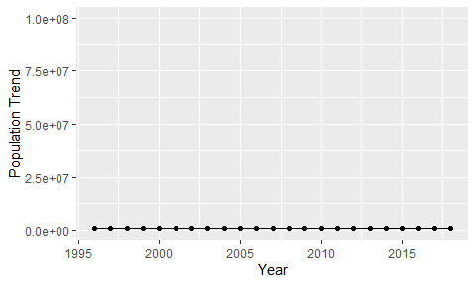

Political Stability Trend

# Population growth trend

The plot shows the population growth rate trend of the country.

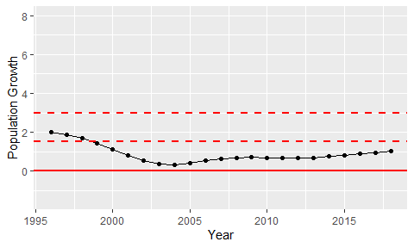

Population Growth Trend